Project Planning Phase
Project Planning (Product Backlog, Sprint Planning, Stories, Story points)

Date | 28 September 2026
Team ID | SWTID-2026-1068
Project Name | BlogNestAPI
Maximum Marks | 4 Marks

Product Backlog, Sprint Schedule, and Estimation (4 Marks)
Use the below template to create product backlog and sprint schedule
Sprint | Functional Requirement (Epic) | User Story Number | User Story / Task | Story Points | Priority | Team Members
Sprint-1 | User Registration | USN-1 | As a user, I can register for AI BlogNestAPI by entering my email, password, and confirming my password. | 2 | High | Murugan, Yuvaraj
Sprint-1 | User Registration | USN-2 | As a user, I receive registration confirmation after successfully creating my account. | 1 | High | Murugan, Yuvaraj
Sprint-1 | Authentication | USN-3 | As a user, I can log into AI BlogNestAPI using my email and password. | 1 | High | Purushothaman, Sakthivel
Sprint-1 | Authentication | USN-4 | As an authenticated user, I can access protected API resources using valid authentication. | 2 | High | Purushothaman, Sakthivel
Sprint-1 | Blog Management | USN-5 | As a user, I can create a new blog post with title, content, and required details. | 3 | High | Mathan, Murugan
Sprint-1 | Blog Management | USN-6 | As a user, I can view available blog posts. | 2 | High | Mathan, Purushothaman
Sprint-2 | Blog Management | USN-7 | As an authorized user, I can update my existing blog post. | 2 | High | Mathan, Yuvaraj
Sprint-2 | Blog Management | USN-8 | As an authorized user, I can delete my existing blog post. | 2 | High | Mathan, Sakthivel
Sprint-2 | Comment Management | USN-9 | As a user, I can add a comment to a blog post. | 2 | Medium | Murugan, Purushoth
Sprint-2 | Comment Management | USN-10 | As a user, I can view comments associated with a blog post. | 1 | Medium | Murugan, Sakthivel
Sprint-3 | AI Content Assistance | USN-11 | As a user, I can submit a prompt to generate AI-assisted blog content. | 3 | High | Purushoth, Murugan
Sprint-3 | AI Content Assistance | USN-12 | As a user, I can receive and use the generated AI blog content through the API. | 2 | High | Mathan, Purushoth
Sprint-3 | Validation & Error Handling | USN-13 | As a user, I receive clear validation errors when required API data is missing or invalid. | 2 | Medium | Purushoth, Yuvaraj
Sprint-4 | Testing & Integration | USN-14 | As a project team, we can test all major API endpoints using positive and negative scenarios. | 2 | High | Murugan, Sakthivel
Sprint-4 | Testing & Integration | USN-15 | As a project team, we can integrate and verify authentication, blog, comment, and AI modules. | 3 | High | Mathan , Murugan
Sprint-4 | Documentation | USN-16 | As a project team, we can document the API, project workflow, and final testing results. | 1 | Medium | Murugan, Yuvaraj, Purushoth

Project Tracker, Velocity & Burndown Chart: (4 Marks)
Sprint | Total Story Points | Duration | Sprint Start Date | Sprint End Date (Planned) | Story Points Completed (as on Planned End Date) | Sprint Release Date (Actual)
Sprint-1 | 20 | 6 Days | 22 Sep 2026 | 27 Sep 2026 | 13 | 28 Oct 2022
Sprint-2 | 20 | 6 Days | 23 Sep 2026 | 28 Nov 2026 | 11 | 28 Oct 2026
Sprint-3 | 20 | 2 Days | 19 Sep 2026 | 20 Sep 2026 | 9 | 20 Sep 2026
Sprint-4 | 20 | 5 Days | 14 Sep 2026 | 18 Sep 2026 | 8 | 18 Sep 2026
3. Velocity
Planned Total Story Points: 80 points
Number of Sprints: 4
Average Planned Velocity: 10.25 story points per sprint
Velocity Note: Actual velocity should be calculated from the story points completed at the end of each sprint. The values above are planning estimates based on the backlog.

4. Burndown Chart
Burndown interpretation: The burndown chart represents the remaining story points against the planned sprint timeline. For AI BlogNestAPI, the planned work starts at 35 story points and reduces as user stories are completed.
Checkpoint | Planned Remaining Story Points | Work Completed
Project Start | 35 | 0
End of Sprint-1 | 22 | 13
End of Sprint-2 | 13 | 22
End of Sprint-3 | 6 | 29
End of Sprint-4 | 0 | 35
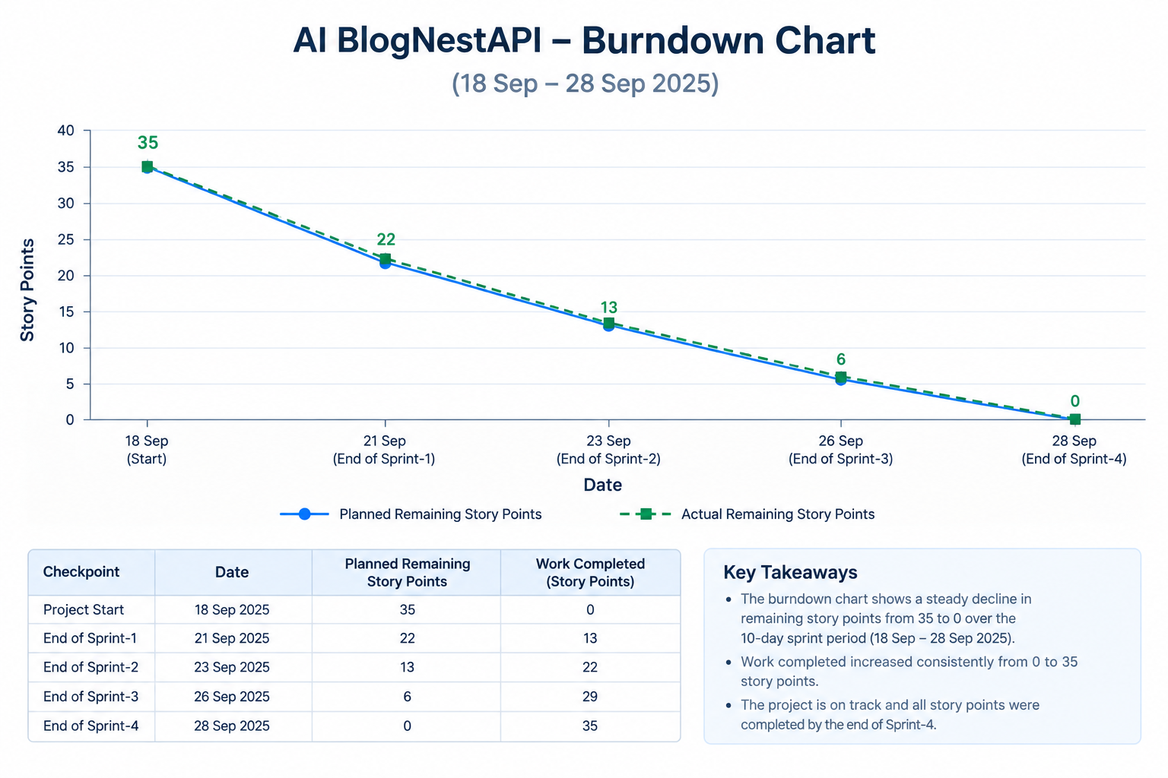

5. Planning Notes
• Priorities are assigned according to the dependency and importance of the AI BlogNestAPI features.
• High-priority work focuses on authentication, core blog CRUD operations, and AI content functionality.
• Sprint scope may be adjusted based on actual progress and technical dependencies.
• Actual completed story points and release dates should be updated after each sprint.
• The burndown chart should be updated regularly to reflect remaining work.
6. Project Planning Summary
Project: AI BlogNestAPI
Planning Approach: Agile / Scrum
Total Planned Story Points: 80
Number of Sprints: 4
Core Modules: Authentication, Blog Management, Comments, AI Content Assistance, Validation, Testing and Documentation

